The Northern King Charles Spaniel Club
Centenary Year 2007 Open Show
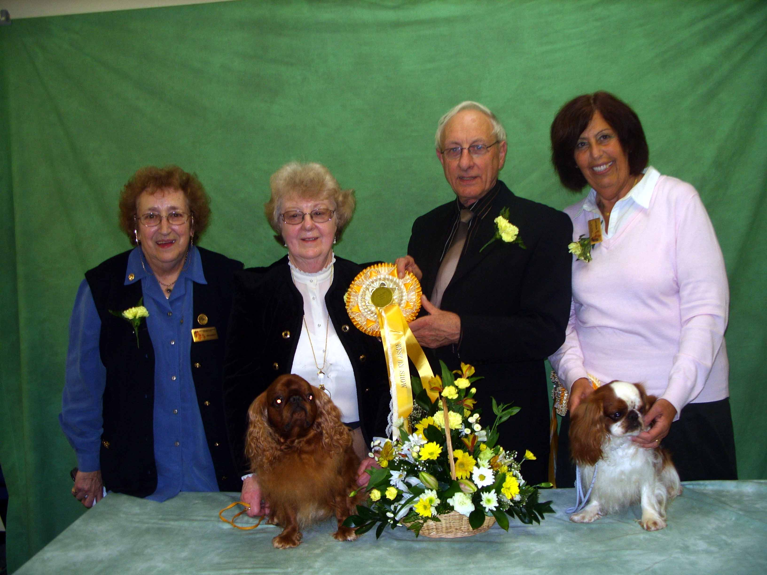
President Mrs D Cooper, Mrs B Plews with Best in Show Tewhit Tedward Bear, Judge Mr A Mochrie
and Mrs G Smith with Justacharmer He Is Our Magic Res Best in Show

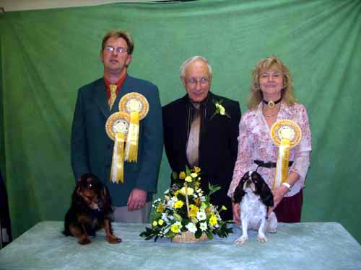
Mr D Anderson with Best puppy Maibee Blue Bayou at Nisyros Judge Mr A Mochrie
and Mrs J Coupland with Tucherish Wkd Antoinette
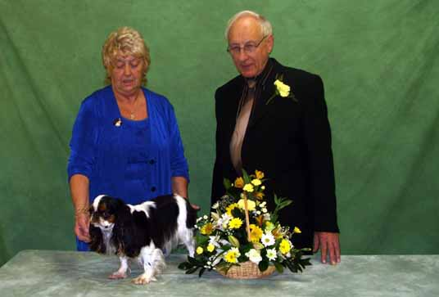
Mrs B Essex with Best bitch Ch Amantra Little Doritt
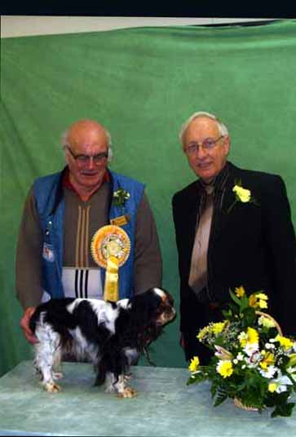
Mr E Plews with the Best Veteran Tewhit Treasure Trove

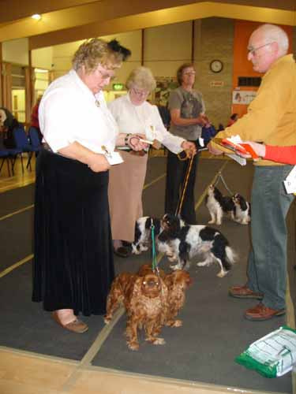
The Brace winners

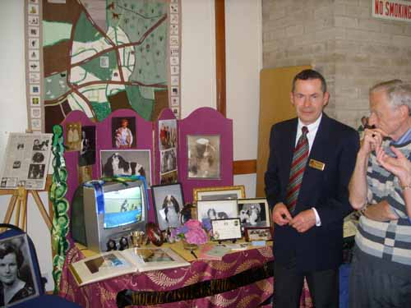
John Castle with his collection of his mothers memorabilia

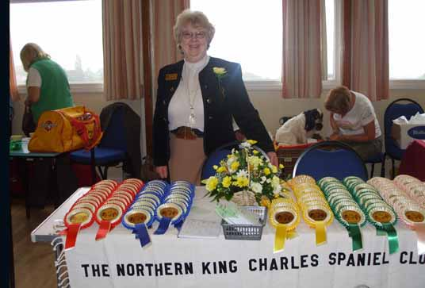
Barbara with the Rosettes

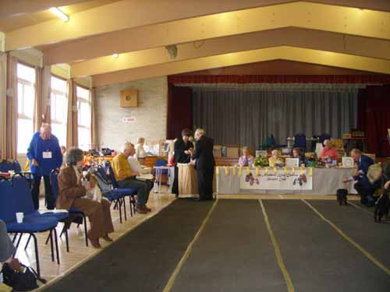
View of the hall

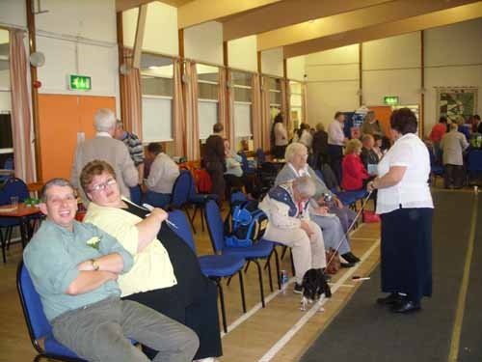
Around the ring

