Border Union - Judge: IAN WATT
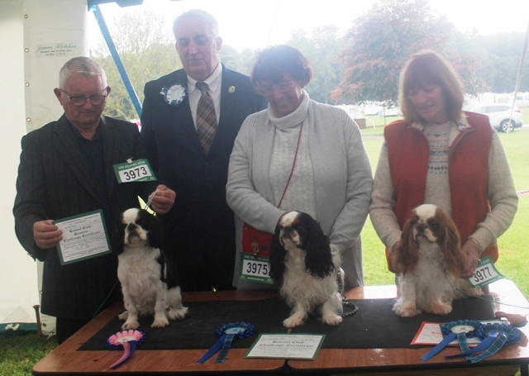
Brian Rix With Best Puppy & Res Bitch Cc Baldragon Fame Game At Ricksbury Naf Taf, Judge Ian Watt, Gill Smith With Dog Cc Justacharma Magic Goes On And Carole Siddle With Bitch Cc Bob & Best Veteran Ch Penemma Misty For Me Jw
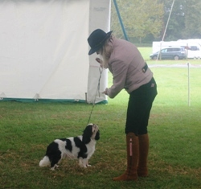
Puppy Dog Winner
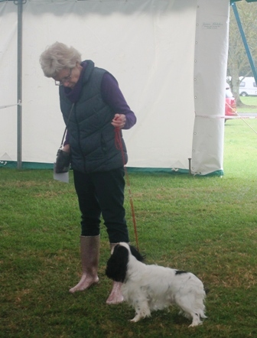
Yearling Dog Winner

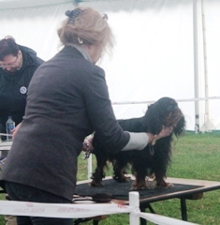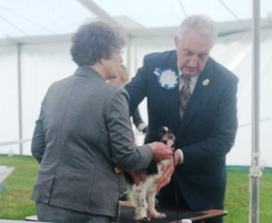

Novice & Graduate Dog 1st & 2nd

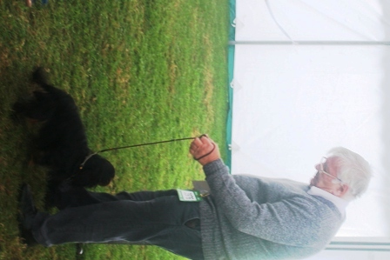
Post Graduate Dog Winner
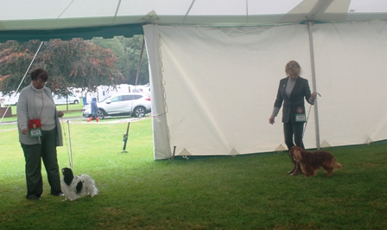
Limit Dog Winners

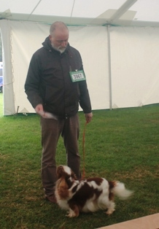
Open Dog Winner

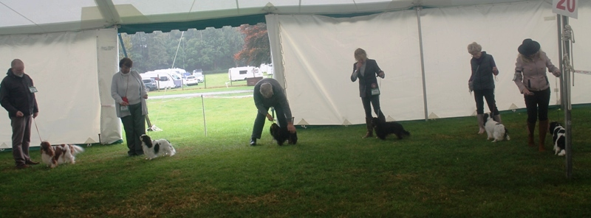
Dog CC Line-up

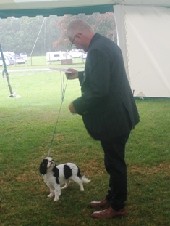
Puppy Bitch Winner
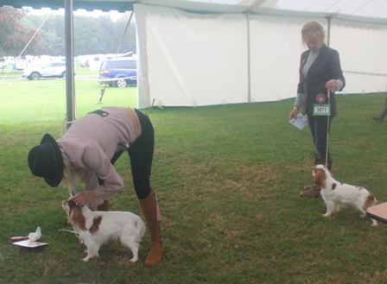
Open Bitch Winners

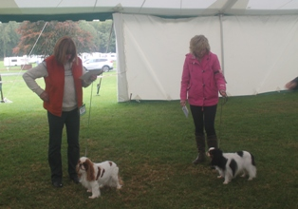
Veteran Bitch Winners

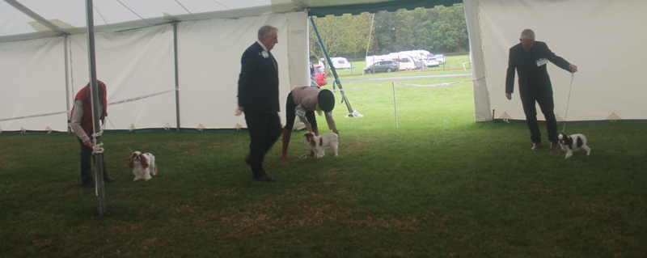
Bitch CC Line-up

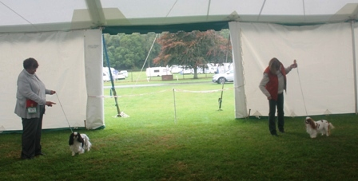
Challenge For BOB

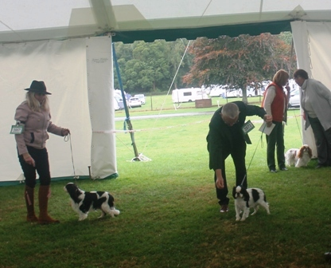
Challenge For Best Puppy

